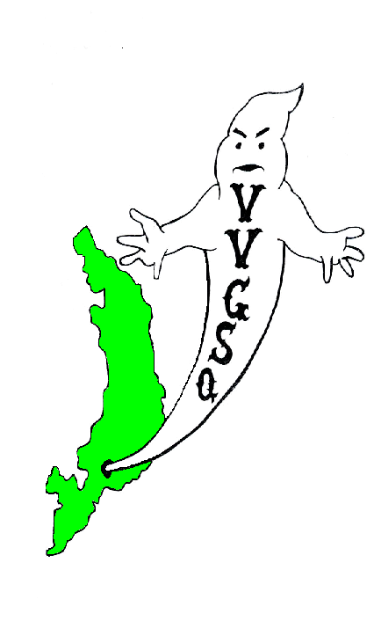
Vietnam Veterans Group of San Quentin

April 2012 General Meeting
Held in the Library on April 22, 2012.

EXECUTIVE COMMITTEE:

Chairman | Ron Self
Vice-Chairman | Barry Spillman
Secretary/Treasurer | Dave Basile
Outside Coordinator | Ron Self (Acting)
North Block Member-at-Large | Malcolm Jones
H-Unit Member at Large | Anthony Parker
West Block Member at Large | Harry Barton

Chairman Ron Self called the meeting to order at 0920 hrs. Roll was called: 38 members present, 4 absent and 1-excused absences - there was a quorum. Our sponsor, Lt. K. Evans, was not in attendance, therefore our meeting was held outside on the lower yard.

All present were asked to remove their hats for a moment of silence to the Missing-in-Action, the Killed-in-Action, and all other service members deployed in Iraq, Afghanistan, and around the world.

All members were asked if they received the March 2012 General Meeting minutes. All members did receive their minutes, no errors were noted, no corrections were requested. A motion to accept the minutes requested by Mr. Barton, seconded by Mr. Johnson, and the motion passed.

SECRETARY/TREASURER'S REPORT:
Mr. Dave Basile: We have $27,589.15 in our account as of 4/11/2012. After payment of our bills the VVGSQ will have funds for the scholarship award(s) and thanks were extended to those veterans who donated to the scholarship banquet.

OUTSIDE COORDINATOR’S REPORT:
Mr. Self: The following correspondence received since our last meeting:

United Veterans of America Freeport, Florida
Chaplain Phillip Carter, NIV Savoy, Texas
Bill Anderson Seattle, Wash.
Kyle Terzian Menlo Park, Ca.
J. Chaney VVA
Gloria Godchaux Operation Moms

COMMITTEE REPORTS:

BY-LAWS:
Chairman Bob Kaser: By Laws for fiscal year 2012-2013 are submitted for approval. They contain the revision voted in September 2011 concerning non-adverse transfers and leave of absences by-passing the 90 day probationary period.

SCHOLARSHIP:
Chairman J. Robinson: The menu for the June Banquet will be completed by Tuesday and submitted to the Secretary for inclusion into the Banquet narrative. Only one application has been received so far.

VIP OFFICE:
The next workshop is scheduled for May 4, 2012.

COLOR GUARD:
Speaking for Mr. Capell was Mr. Basile. The Color Guard is presenting Colors during the Patton College Graduation ceremonies during the month of May. Opening Day for the San Quentin Giants baseball season is still to be determined. Mr. Basile will advise Mr. Capell when that date is. On May 28, 2012 the Alliance group is requesting the Color Guard at their banquet. In addition, Veteran Johnson suggested that the Color Guard assemble on the yard at approximately 1200 hrs on Memorial Day (May 28). At this time, the Color Guard will present our Colors with the VVGSQ assembled while veteran Fasion plays taps. The membership will be informed if this event is conducted.

HISTORIAN/WEBSITE:
Mr. Self indicated the update to our Website with current photos and minutes.

STAMPS FOR SOLDIERS:
Mr. Rooke stated that stamp and tab collections are coming along fine. Collection envelopes have been placed throughout each housing unit and visiting rooms.

FOOD SALE:
Mr. Rooke informed the members who will be participating in the food sale on April 29 and what areas they will be working in.. All members were asked to appear on the yard Saturday April 28, to unload the truck. Lt. Luna stated he will be on grounds between 0830 hrs and 0930 hrs. Secretary Basile, responding to veteran Warren’s question as to why no inmates from H-Unit are involved in the food distribution process replied as follows; as there are currently 43 members in our group, roughly half will be involved in the food sale. Because those in H-Unit are Med-A custody and not required to report back to their units for Close custody count, it was decided to best utilize those veterans in the Banquet set-up and clean up crews. Finally, all members, who are not participating in the food sale whether they submitted an order or not, must come to the food sale as if you did submit an order.

PRESENTATION BOXES:
Chairman Schuhmacher expressed thank for the PIA workers who are currently assigned the task of making the presentation boxes. Not mentioned, but worth noting; Mr. Phillip Early, USAF ret., PIA Plant Manager gave the VVGSQ permission to make the boxes in PIA. Many thanks to Mr. Early. In addition, they are practicing transferring the military logos through the engraving process. Chairman Schuhmacher requested that Mr. Sanez be included on the guest list for the banquet.

OLD BUSINESS:

Secretary Basile asked Sgt. of Arms Robinson to escort the following probationary members; Cooper, Goodlow, Hernandez, Stewart, Tarvin, and Farris to a neutral area. At this time the General Body was asked if there were objections or support for these members to be included in the VVGSQ. Several members voiced their support and each probationary member was voted in unanimously by the General Body. There is one new member who I failed to introduce, Veteran Marvin Harris, US Army. He will be introduced to the group at our May meeting.

NEW BUSINESS:

Secretary Basile raised the question regarding bringing Lt. Luna on board as a Co-Sponsor to our group. Veteran Johnson made the motion with Veteran Barton as the second. A vote was taken and the motion passed unanimously. Congratulations, Lt. Luna. Veteran Hernandez addressed the group, introducing the idea of bringing the ½ scale replica of the Vietnam Memorial Wall to San Quentin. The cost is approximately $5,000 but may be less. A motion was raised by Veteran Sanders to pursue this matter. It was seconded by Veteran Self and the motion passed. In addition, Veteran Johnson raised the idea of the Color Guard for Memorial Day (See Color Guard Committee).

A motion to adjourn the meeting by Mr. Sanders and seconded by Mr. Warren. A vote was taken and the motion passed. The meeting adjourned at 1007 hrs.

UPCOMING EVENTS

April 28, 2012 | Members to unload truck @ Gym; Time TBD
April 29, 2012 | Food Sale @ Gym
May 27, 2012 | General Meeting in the Library @ 0900 hrs (Tenative)
June 17, 2012 | Scholarship Banquet, Visiting Room San Quentin
June 24, 2012 | General Meeting in the Library @ 0900 hrs

Submitted,

__________________________ __________________
D. Basile, DATE
V.V.G.S.Q. Secretary / Treasurer

__________________________ __________________
R. G. Self DATE
V.V.G.S.Q. Chairman

NOTED

__________________________ __________________
R. Luna DATE
Correctional Lieutenant
V.V.G.S.Q. Co Sponsor

Vietnam Veterans Group of San Quentin  Attn: Lt. K. Evans, Chief sponsor  San Quentin State Prison  1 Main Street  San Quentin, CA 94964-0001  Website: http://vvgsq.tripod.com/ | Chief Sponsor: Lt. K. Evans, (415) 454-1460 x 6047  Co-Sponsor: Lt. R. Luna, (415) 454-1460 x 5808

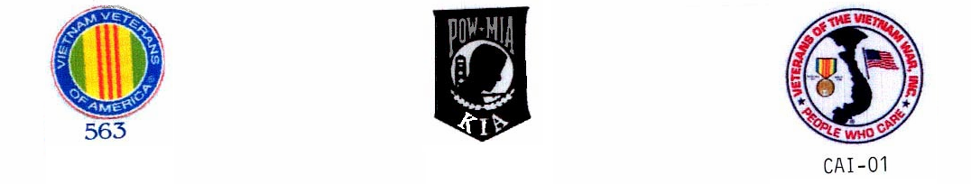
CURRENT ROSTER as of 3/25/12

 |  | NAME | CDC # | HOUSE | ETH. | CUST. | STATUS | COMMENTS
1 | √ | ADAMS DWIGHT | K-98701 | 1N073L | BLK | CLOB | Voting Mbr
2 | √ | ARNOLD, RICHARD | P-27171 | 2N069U | WHI | CLOB | Voting Mbr | VIG
3 | √ | BAER, STAN | K-06285 | 3N039U | WHI | MEDA | Voting Mbr | VIG,
4 | √ | BARTON, HARRY | C-03120 | 1W037L | WHI | MEDA | Voting Mbr | VIG,W-Blk Mbr @ Large,
5 | √ | BASILE, DAVID | C-70016 | 1N038U | WHI | MEDA | Voting Mbr | VIG, Secretary/Treasurer
6 | √ | BEAVERS, LAWSON | P-14974 | 1N015L | BLA | CLOB | Voting Mbr | VIG, Color Guard
7 | A | BROWN, DAVID | AE-3137 | 3W003L | BLA | MEDB | Voting Mbr
8 | √ | BUTLER, DUANE S. | D-91464 | 2N017L | BLA | MEDA | Voting Mbr | VIG
9 | √ | CAFFALE, GEO | D-97941 | 3N008L | WHI | MEDA | Voting Mbr | VIG
10 | √ | CAPELL, TRENTON | E-91949 | 3N011U | BLA | CLOB | Voting Mbr | Chairman Color Guard
11 | √ | COLEMAN, RONALD | C-87435 | 2W010L | BLA | MEDA | PROBATION | Probation until 5/27/12
12 | √ | COOPER, GARY | T-15604 | 3W013L | WHI | CLOB | Voting Mbr
13 | A | FAISON, POPEYE | C-68462 | 2N028U | BLA | MEDA | Voting Mbr
14 | √ | FARRIS, DARRYL | T-33812 | 5N071U | BLK | CLOB | Voting Mbr
15 | √ | GOMEZ, JOHNNY | K-72622 | 4N042L | MEX | CLOB | Voting Mbr
16 | √ | GOODLOW, KENNETH | C-75705 | 3W102L | BLA | CLOB | Voting Mbr
17 | √ | GUMPAL, MAURO | P-00591 | 4N036L | OTH | CLOB | Voting Mbr
18 | √ | HARRIS, MARVIN | C91589 | 2W093L | BLA | MEDA | PROBATION | Probation until 7/29/12
19 | √ | HERNANDEZ, JESSE | K-21116 | 2W036L | WHI | MEDA | Voting Mbr
20 | √ | HYLTON, ROBERT | AI4554 | 4H077L | WHI | MEDA | PROBATION | Probationary until 6/24/12
21 | √ | JOHNSON, CRAIG | C-08327 | 4W063L | WHI | MEDA | Voting Mbr
22 | √ | JONES, MALCOLM | J-04780 | 4N008L | BLA | CLOB | Voting Mbr | VIG, NB Member at Large
23 | √ | KASER, BOB | D-41415 | 2N025L | WHI | MEDA | Voting Mbr | VIG, Chairman Bylaws
24 | √ | KESS, PHILLIP | G-62396 | 05H074L | BLA | MEDB | Voting Mbr
25 | √ | MARTIN, J.D. | D-44170 | 4W075L | BLA | MEDA | Voting Mbr
26 | E | PARKER, ANTHONY | D-20753 | 05H006L | BLA | MEDB | Voting Mbr | H-Unit Member at Large
27 | √ | POLLEY, AHMAD | C-57727 | 2W084L | BLA | MEDA | Voting Mbr | VIG, Color Guard
28 | √ | ROBINSON, GARVIN | K-52086 | 3N012L | BLA | CLOB | Voting Mbr | Scholarship Chairman, Color Grd
29 | √ | ROOKE, PETE | C-76159 | 1N020L | WHI | CLOB | Voting Mbr | Tabs/Stamps for Soldiers
30 | √ | SANDERS, GREG | E-05222 | 2W011L | WHI | MEDA | Voting Mbr | VIG, Outside Coordinator
31 | √ | SCHUHMACHER, CHRIS | T-31014 | 4N093L | WHI | MEDA | Voting Mbr | Presentation Box Chairman
32 | √ | SELF, RONALD | K-21055 | 4N083L | AMI | CLOB | Voting Mbr | VIG, VIP, Chairman
33 | √ | SNIDER, JAMES | F-30077 | 2N100U | WHI | CLOB | Voting Mbr | Scholarship
34 | √ | SOLTERO, DANIEL | D-65858 | 1W074U | WHI | CLOB | PROBATION | Probation until 5/27/12
35 | √ | SPILLMAN, GLEN | F-42695 | 3N035U | WHI | CLOB | Voting Mbr | VIG, Vice Chairman
36 | √ | STAUFFER, PAUL | T-80750 | 3N065U | WHI | CLOB | Voting Mbr
37 | √ | STEWART, NORFLEET | E-90026 | 4W079L | BLA | CLOB | Voting Mbr
38 | √ | STONER, JEFFREY | D03596 | 5W085U | WHI | MEDA | PROBATION | Probationary until 6/24/12
39 | √ | TARVIN, DAVID | E-76518 | 2W038L | WHI | MEDA | Voting Mbr
40 | A | TREVENO, DANNY | J-93154 | 4W012L | AMI | CLOSB | Voting Mbr | Scholarship
41 | √ | VICK, ERNIE | P-59262 | 2N016L | WHI | CLOB | Voting Mbr | VIG, Scholarship
42 | √ | WARREN, JOHN | T-86358 | 04H065L | MEX | MEDB | Voting Mbr
43 | A | WOODS. JIMMIE | V-68113 | 03H022 | BLA | MEDB | PROBATION | Probation until 5/27/12

√ = Present
E = Excused Absence
A = Unexcused Absence

